**Medellín, January 12, 2023**

**RELEVANT INFORMATION**

_________________________________________________________

**Sebastián Castañeda Arbeláez, Interconexión Eléctrica S.A. E.S.P. (ISA)'s new Chief Growth and Business Development Officer**

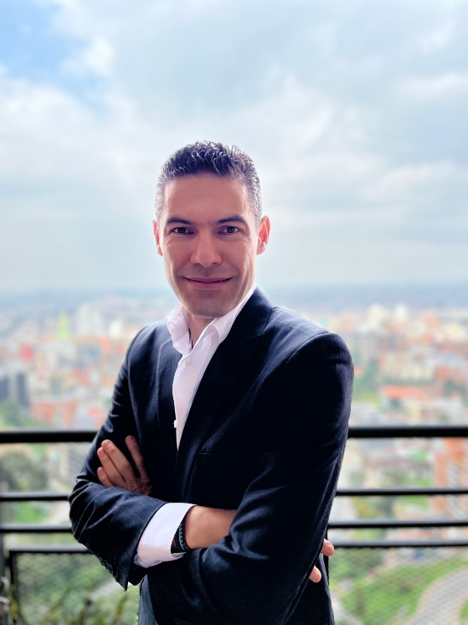

Interconexión Eléctrica S.A. E.S.P. (ISA) informs that Sebastián Castañeda Arbeláez will take over as Chief Growth and Business Development Officer as of February 1, 2023.

Sebastián has held leadership positions for more than 19 years and has been a member of the board of directors of several companies in the mining and energy sector. He served as Corporate Manager of Financial Planning and Business Performance of the Corporate Vice-Presidency of Finance of Ecopetrol, where he has worked for more than 17 years in technical, financial, and project areas. Before joining ISA, he led corporate processes related to portfolio and capital allocation, financial planning, business performance, and projection of prices and rates. Also, he led the construction of the Ecopetrol Group's medium-term business plan.

His most remarkable achievements include strengthening the Ecopetrol Group's diversified investment portfolio, overseeing the process to maintain strict capital discipline, his work to improve investment placement capacity, and his leadership in redefining and adjusting the Group's business plan during the recent crises. Additionally, he was in charge of the Ecopetrol Group's Investment Committee, led the analysis of the long-term portfolio as input for the definition of the new “Energy that Transforms (Energía que Transforma)” strategy, simplified the business performance model for a greater focus and alignment, and was part of the team in charge of large transactions such as the purchase of 51.4% of ISA and the expansion of the unconventional business in the Permian Basin in the United States.

Sebastián is a civil engineer from the Universidad Nacional de Colombia with an MBA from the Massachusetts Institute of Technology (MIT). He has two master's degrees: civil engineering with a concentration in construction management, and administration with a concentration in finance, both from Universidad de los Andes. He also completed the CFO program at Columbia University.

As Chief Growth and Business Development Officer, Sebastián Castañeda will face important challenges, such as pursuing the 2030 USD 12.5 billion investment target, which includes USD 2.2 billion in new geographies and USD 2 billion in new energy businesses, as well as to continue strengthening ISA's presence in the region.